Pair-Share: Strategies for Success
Form strategic partners
- Establish pair- share partners
- Mix the students, not always lowest with lowest or highest with highest
- Periodically rotating partners, allows students to work with different people
and balance out abilities
State which partner should go first
- This alleviates one student doing all the talking
- Use cues such as ‘Switch, Partner A talk now.’ Or ‘Partner A, explain to Partner B’
Encourage active listening
- Partners must be talking and listening to each other during pair-shares
- Young students can sit ‘knee-to-knee’
- When the pair-share is completed they can go back into ‘listening position’
- Students at desks should be speaking to each other rather than talking into space
Repetitive tasks can be split among partners using point and explain
“Partner A solve problem number 3. Partner B solve problem number 4.
When you are done show your partner how you solved it”.
- Include students explaining how a problem was solved while physically pointing to it
- A variation is having students point and explain something on their partner’s whiteboards.
Academic vocabulary
- Always have students answer in complete sentences

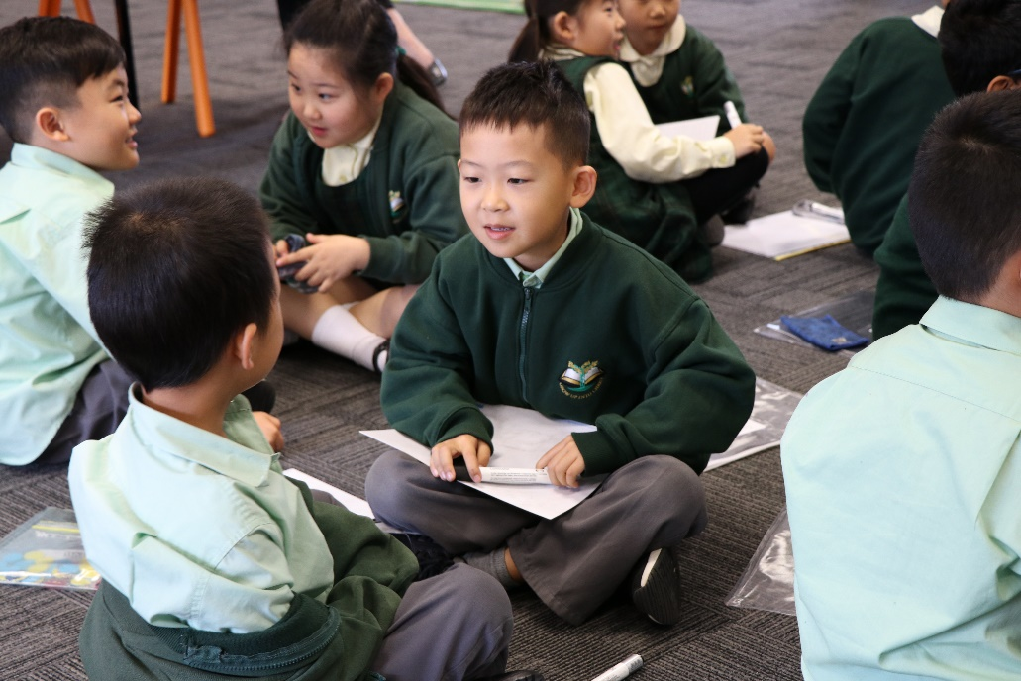
Why Pair-Share is so effective

- Every student orally answers every question: Pair-shares goes beyond having students think of an answer. Now they are actually saying the answer out loud.

- Automatic wait time is embedded: Pair-shares provide the wait time for all students to prepare an answer.

- Listening and speaking is included: Pair-shares are the primary method of including listening and speaking strategies in every lesson. It is especially effective because pair-shares can include practice of academic vocabulary from the lesson.

- Student engagement improves: During pair-shares all students are engaged.

- Students remember more: Pair-share is also a cognitive strategy. As students discuss the information, they are also facilitating remembering the information.

- Increases the student-talk to teacher-talk ratio: Consistent pair-shares adds student talk to the lesson.

- Students practice their answers: During pair-shares, all students are practicing putting together the sentences they will respond with.

- Short attention span addressed: Pair-shares help students with short attention spans. As it breaks up the length of time they must listen quietly to the teacher.

- Provides first reteach: During pair-shares you ask the students to explain their answers to each other. You can check for errors if they then give different answers.

- Classroom management improves: Having students’ pair-share improves classroom management, as they are actively participating in a directed, whole-class academic activity.

- Instruction is more interactive and interesting for the students: Pair-share is a great way to create student interactions. Lessons are always more interesting for students when they do something.

- Academic socialisation increase: Students are interacting with each other, speaking in academic English rather than conversational English.

- Affective filter is reduced: Students reluctance to use language in front of others is reduced because they practise answering questions with one person, before being called upon to answer in front of the whole class.

- Teachers’ aides can be used strategically: Pair-shares can provide opportunities for other staff to be helping students.
Reference: DataWorks

