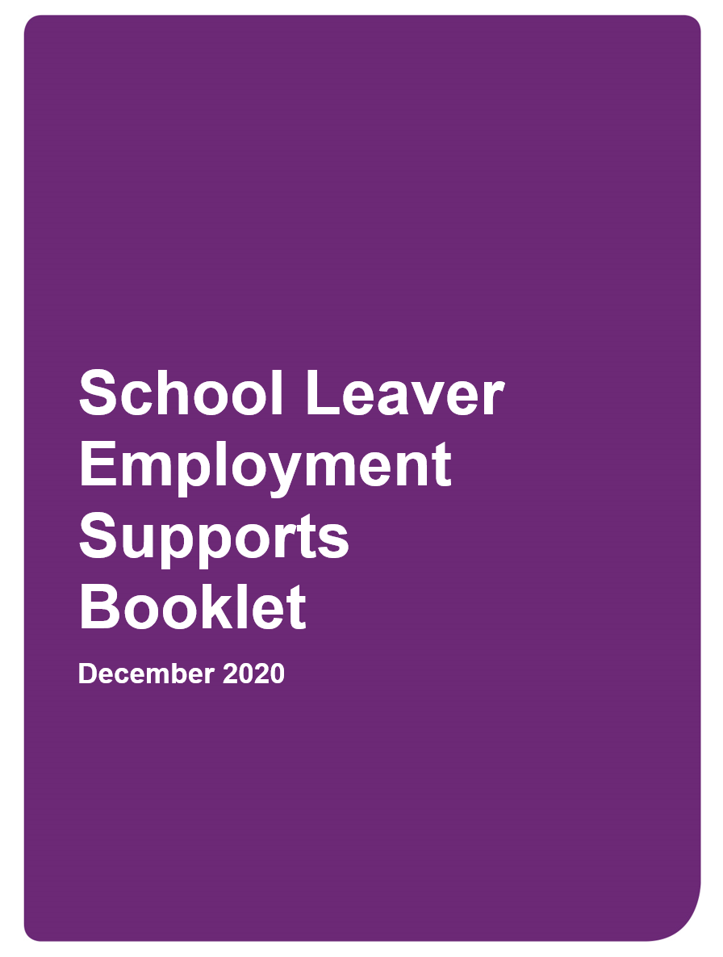

Contents

NDIA supporting participants to find and keep a job 3
School leaver employment supports 3
What are school leaver employment supports? 4
Who are school leaver employment supports for? 4
When is funding included in a plan? 5
How can school leavers with a disability join the NDIS? 5
Participant experience 6
How do participants select a provider? 6
What is a service agreement? 6
What type of supports can participants expect to receive? 7
Provider role and responsibilities 7
The important role of providers 7
Provider registration 8
Provider expectations 8
Outcome measures, reporting and claiming 9
Outcome measures and reporting 9
NDIS provider reporting tool 9
Claiming for school leaver employment supports 10
More information 10

NDIA supporting participants to find and keep a job
In 2019, the National Disability Insurance Scheme (NDIS) released the NDIS Participant Employment Strategy to set a plan for supporting NDIS participants to find and keep a job. The goal is to have 30% of participants of working age in employment by 30 June 2023.
There are many benefits to having a job like expanding social networks, raising living standards and increasing financial independence and self-worth.
The NDIS wants to help participants who want to work, to get a job they like and keep it.
This booklet focusses on one of the transition to work options available to NDIS participants of school leaving age – school leaver employment supports.
It is a resource for participants, their parents/carers, providers, teachers and stakeholders to learn about school leaver employment supports. It also outlines the NDIA’s expectations of service delivery and outcomes.

School leaver employment supports
When an NDIS participant leaves school, they have a number pathways and supports available. Their choice depends on their aspirations, skills, abilities, interests, and personal and family circumstances.
Pathways
- further education or training
- employment in an apprenticeship or traineeship
- independent job seeking
- volunteering
- community participation.
Supports
- School leaver employment supports to transition to employment (once they develop the necessary skills)
- Employment supported by mainstream supports such as a Disability Employment Service (DES) or other community based or informal support network.
- Ongoing supports in employment funded in a participant’s plan and delivered in a range of workplace settings including Australian Disability Enterprises (ADEs), social enterprise, public or private employer, self employment or a family run business.
Some participants may choose one or a mix of pathways and supports. Supports can be in place at the same time or one at a time.
School leaver employment supports are one of the funded employment supports, along with:
- employment related assessment and counselling
- individual or group based assistance employment workplace assistance
- supports in employment (previously known as Supported Employment).
It is a good idea to start thinking about and planning for life after school before the last year. A helpful place to start is the Let’s talk about work page on the NDIS website. It also has a link to a booklet that covers:
- planning for employment
- exploring employment goals
- planning for leaving school
- finding employment providers.

What are school leaver employment supports?
School leaver employment supports form the critical bridge between school life and work.
These supports:
- help school leaving aged participants explore and understand their work potential
- focus on capacity building, developing skills, independence and confidence to work
- are tailored to the individual and their unique pathway to employment
- are available during the final years of school and directly after leaving school, generally up to two years
- are reviewed periodically to make sure the supports are meeting the participant’s goals.
School leaver employment supports should not be delivered as a program or take a one-size-fits-all approach.
These supports are person-centred, individually tailored, strategic and planned so participants of varying skills and needs can reach their employment goals.
These supports are individualised, with a strong emphasis on trying and testing through work experience in a range of settings.
Trying and testing helps participants be better prepared for work, where the activities inform the level and type of supports that a participant may need to get and keep a job.
With the right combination of school leaver employment supports, participants may:
- move into employment or job seeking (sometimes with the assistance of a Disability Employment Service provider)
- progress to self-employment.
Some participants may need longer term supports to get or keep a job.

Who are school leaver employment supports for?
School leaver employment supports are available to NDIS participants in their final year of school and those who have recently left school (generally up to age 22).
These supports are typically for Year 12 students, but can be considered for any student who has reached school leaving age and is looking to transition from school to work. The legal schooling leaving age varies across states and territories in Australia.
While some participants may be ready to move straight into looking for work after school, many need additional supports to help them learn more about work and what it might look like for them.
School leaver employment supports help participants understand their employment potential, and gain the skills and confidence to work towards their employment goals.

When is funding included in a plan?
The NDIS funds supports for participants to help them prepare for work, find a job and have ongoing supports when at work.
Funding is based on the participant’s employment goals, individual circumstances and reports/assessments provided during the planning conversation.
During that conversation, the type of information that will assist the planner to make reasonable and necessary funding decisions includes:
- information in the Let’s talk about work booklet (which the participant should complete)
- recent school reports
- work experience reports
- references or reports from part-time work or volunteering activities
- school career transition plan
- vocational profile
- reports or assessments from professionals (such as Functional Capacity Assessment completed by an occupational therapist or a Vocational Interest Report from a counsellor).
These help the planner to identify the nature of supports, both through the NDIS and other government services, and enables a participant to achieve their employment goals.
Planning conversations should happen while a participant is still at school. This is to make sure there is funding to help with transition planning in their last 6 months before leaving school.
Many students are interested in after-school and weekend work. Experience during school years can be helpful for students when entering the workforce after school.
While school leaver employment supports are included in plans in the final school year, participants should discuss their employment plans with their local area coordinator (LAC) or planner throughout their secondary school years.
Participants can use the Core and Capacity Building funds in their plan to develop work skills and have supports in part-time employment or community activities, such as volunteer work.

How can school leavers with a disability join the NDIS?
If a student with a disability is leaving school and is not an NDIS participant, they need to:
- meet NDIS eligibility criteria
- complete and submit an access request.
More information on the Applying to access the NDIS page is on the NDIS website.

Participant experience
The NDIA encourages participants to look for providers that are a good fit for their needs. This may be done with the help of their family, other support person or school transition teacher.
Participants can also:
- speak to their LAC or support coordinator
- look for useful information available online
- attend school leaver events and speak to providers about school leaver employment supports
- seek advice from people with school leaver employment supports experience, including recent school leavers and their parents.

How do participants select a provider?
Participants should choose their NDIS providers carefully. Meeting with or discussing service options with a number of providers before making a decision can be helpful to build their knowledge about the supports participants are most interested in receiving.
To help them decide, participants may want to ask questions about:
- types of support the provider offers
- the organisation’s outcomes
- any targeted disability services provided for example, specialising in services for participants with a particular disability.
As a customer, a participant has a choice of provider, the types of support they think will best meet their needs and how they would like them delivered. A participant can also choose to be supported by more than one provider.
Participants are encouraged to work with providers who develop tailored plans designed to increase their capacity and skills.
The Provider Comparison Worksheet has suggested questions to ask providers.

What is a service agreement?
A provider should prepare a service agreement once a participant has chosen them to deliver supports.
The service agreement is a formal document that details an agreed set of expectations between the participant and provider.
More information is available on the Making a service agreement page on the NDIS website.

What type of supports can participants expect to receive?
School leaver employment supports must be tailored to meet the participant’s individual employment goals. Work experience in an inclusive employment environment should be offered, to fully understand a participant’s support needs.
Participants should expect providers to create individualised supports to help them transition from school to work, engaging with their families and carers around the participant’s goals.
Depending on the participant’s employment goals and their current skill level, the supports to develop ‘hard and soft skills’ may include, but are not limited to:
- social and business communication
- money management
- travel training
- personal hygiene and personal presentation
- workplace norms, behaviours and expectations
- understanding rights and responsibilities in the workplace
- teamwork
- decision making and problem solving
- planning and organising
- working independently
- time management and prioritising
- conflict resolution and negotiation
- building resilience
- accountability
- flexibility
- self motivation and self determination
- computer literacy
- life skills and personal administration
- how a participant can sell themselves and their unique service offering
- resume preparation and job search strategies
- submitting a job application
- interview preparation
- recruitment paperwork preparation
- preparing for a participant’s first day and induction.
Participants and providers must also discuss the different employment pathways and employment types. This will help participants to better understand their work options.

Provider role and responsibilities

The important role of providers
The NDIA recognises the importance of delivering high quality, person-centred supports and services to help participants achieve their goals.
Providers can help build partnerships in the local community. As part of managing barriers to employment, providers can work with LACs to facilitate access to mainstream supports such as health, mental health, education and justice systems.
Providers of school leaver employment supports will help young people to aspire to employment by providing meaningful, individualised capacity building activities.
Providers should use their employer and professional networks and develop innovative business practices to help participants achieve their employment goals.

Provider registration
Providers wanting to deliver school leaver employment supports should be registered to deliver ‘Assistance to Access and Maintain Employment or Higher Education’. For more information, visit the NDIS Quality and Safeguards Commission (NDIS Commission) page.

Provider expectations
The NDIS Commission sets clear expectations for provider behaviour through the NDIS Code of Conduct. Providers and their employees must comply with the Code.
Providers should work with participants to help them identify their skills and strengths to get ready for work and plan their pathway to employment, noting that:

- Some participants may achieve their goals within a few months, while others take longer.
- Some participants may change their minds about the type of work they want to do.
- If a participant has not achieved all of their goals at the end of 2 years, they may require additional supports to successfully transition into employment.
- Some participants may be referred to a Disability Employment Service for further supports.

School leaver employment supports is not a program. They are individualised supports. Providers need to tailor activities to meet the participant’s employment goals.
It is also important to consider the needs of participants and their families when transitioning from a structured school environment. Participants may at first seek regular activity and structure, while others will be ready for a highly individualised experience.
The provider and participant should develop a schedule of activities, reflected in the service agreement, which will help the participant to reach their employment goals. Through the service agreement, the participant and provider will agree on the nature of supports and whether they are delivered in a group, individually, or a combination of both.
Providers are expected to be responsive, innovative and have strong contacts with the community, employers and other relevant service providers.
This will help facilitate a seamless transition with the right support, either into employment or to another service provider, who can further assist the participant to realise their employment goal and meet specific needs.
Such assistance could include:
- provision of assistive technology
- job search and job placement
- job design, on-the-job training and other such supports once a job is secured
- ongoing support in a workplace to keep a job
- arrangement of necessary workplace modifications
- arrangement of wage subsidies to employers and/or other financial support once a job is secured.

Providers should give participants a progress report and suggested pathways to employment that they can take to their planning meeting.

Outcome measures, reporting and claiming

Outcome measures and reporting
Providers of school leaver employment supports must regularly track progress towards the participant’s goals, in accordance with their individualised plan. This is an opportunity to look ahead, refine agreed actions and review past achievements.
Goals can be short, medium and longer term. They should be specific, measurable, achievable, relevant and time-bound (SMART) and outlined in the participant’s individual plan.
The reports should be easily understood by participants and include the following:
- A summary of the goals, milestones, timelines, and services to be delivered through the plan.
- Detail on the progress made towards goals since the start of the plan and during the current reporting period.
- Evidence of progress towards the plan goals including photographs, videos, audio recordings, work experience and other reports.
- A rating scale with an indication of the level the participant is currently at for each goal or skill area and comments to justify the rating. An example of a rating scale could be:
1 = beginning / working towards and not yet achieved
2 = developing / achieving sometimes
3 = developed / always achieving

NDIS provider reporting tool
Providers need to report on the nature and outcomes of school leaver employment supports through the NDIS provider reporting tool. This information allows the NDIA to monitor and evaluate funding outcomes and is available on the School leaver employment supports page of the NDIS website.
The NDIS provider reporting tool must be submitted quarterly to provider.support@ndis.gov.au.

Claiming for school leaver employment supports
School leaver employment supports are a capacity building support for students transitioning from school to employment.
Participant funding is annualised amount, rather than a set number of hours.
All employment support items, including school leaver employment supports, are listed in the NDIS Price Guide, under the ‘finding and keeping a job’ support category.
All claims for payment are subject to the NDIA Payment Assurance process. Providers must keep accurate records of supports delivered and failure to do so may result in monies having to be repaid to the NDIA.
Providers can only claim payments after delivering a service. The frequency of claiming should be agreed with the participant and outlined in the service agreement.
A provider can no longer claim payments for a participant when service delivery ceases.
Service delivery typically ceases at the end of the service agreement or successful transition to:
- employment
- another service provider
- mainstream vocational activity.
This might be, for example, a DES provider, another NDIS provider, a state-based employment program or vocational education training.

More information
For participants:
- Leaving school page on the NDIS website
- Let’s talk about work page on the NDIS website
For providers:
- School leavers employment supports page on the NDIS website
You can also phone the NDIS on 1800 800 110 or go to the contact page of the NDIS website.

